NLP Assignment 4

Intent
As a part of this assignment , I implemented the Naive Bayes Classifier and also tried experimenting with bigrams .
Task Accomplished
    - Implemented the Naive Bayes Classifier without smoothing and with Laplace smoothing on the Spam and Ham dataset
    - Used the Naive Bayes Classifier on the reviews dataset available at Polarity dataset in order to analyze the sentiments (Positive/negative reviews) .
    - Incorporated the bigrams to be used alongside the Bayes classifier . Instead of word independence , I assumed each word was dependent on its predecessor (bigrams) and experimented with this system

Task 1 : Naive Bayes Classifier with and without Smoothing
The first task involved running the Naive Bayes Classifier on the spam and ham dataset . I divided the data into 1200 for training and 200 for testing . I implemented Laplace smoothing to take care of the unknowns .
The statistics I presented included accuracy , Precision , Recall and the F1 score . The results were very promising for the spam , ham dataset
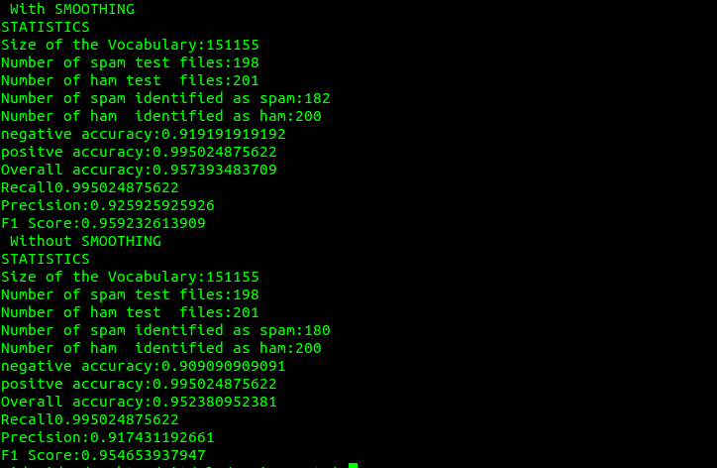
Analysis :
The results are extra ordinary with/without smoothing . However with Laplace smoothing , we see an improvement . This just goes to show that giving some probability to the unknowns does improve the effectiveness of the Classifier

Task 2 : On the Reviews Dataset
The second task was to use the Naive Bayes Classifier on the reviews dataset to perform sentiment analysis . This dataset just analysis the polarity of the review ( Positive/negative) . I divided the dataset into 900 for training and 100 for testing for both positive and negative reviews.
When I ran the Naive Bayes Classifier on the original dataset , the accuracies were average . Here are the results
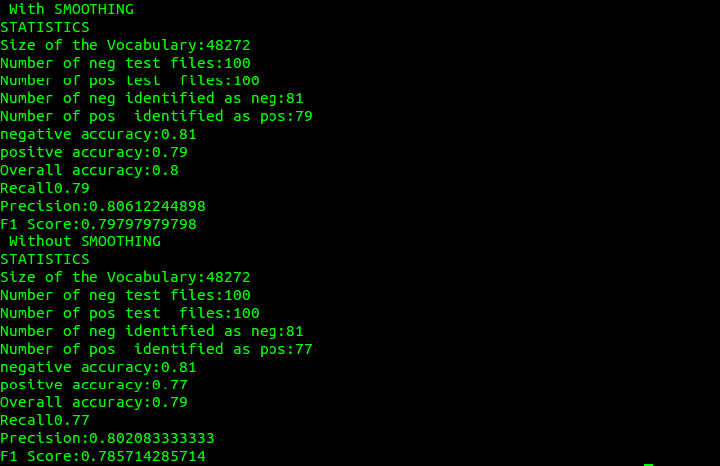
When , I had a look at the reviews , I realized that they were raw text and hence , I decided to perform some preprocessing and removed all the stop words from the files and re ran the test on the clean negative and positive reviews
The results in this case seemed to improve a bit , but the improvement was not substantial .

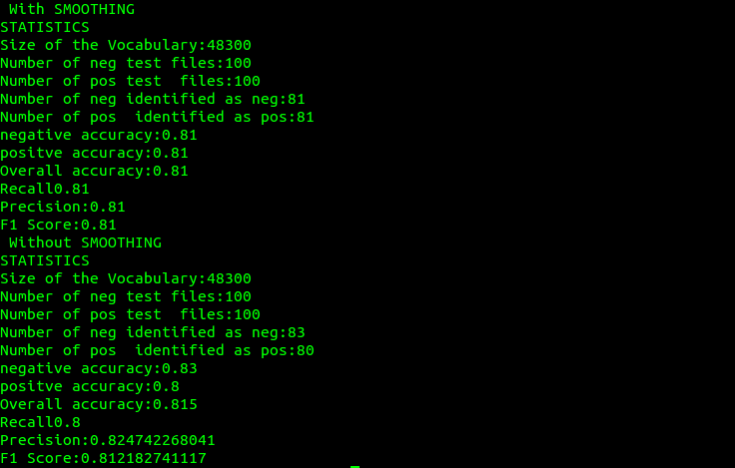
Analysis :
From all the above results it is clear that the smoothing need not improve the classification all the time ( in the last case) . Moreover the Naive Bayes Classifier does a pretty good job in classification which means we should be able to do better , if we assume some dependence between words in the text .

An Interesting Experiment :
I wrote a movie review which had both positive and negative words in it
The results given by the system :
It is very encouraging to see that the log probability for both positive and negative are so close in this case.

Task 3
I had implemented the bigrams.py as a part of the previous submission . Then I was thinking , if the bigrams were to be used with the Bayes Classifier , it would produce better results and instead of assuming word independence , I said each word was dependent on its predecessor and made use of the bigrams.py

When the bigram bayes classifier was applied to the spam and ham dataset :
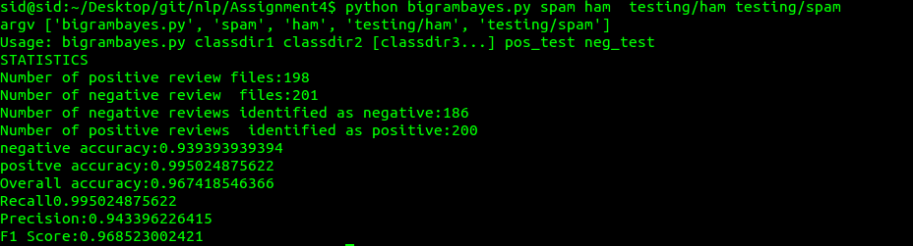
For the reviews dataset :
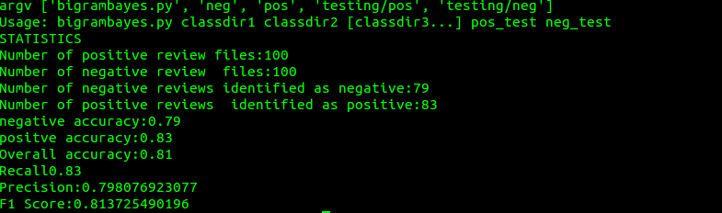
The results seem to be on par or slightly better than the Naive Bayes Classifier .

